Code With Me – Machine Learning and AI Install Instructions Documentation

This setup requires that you have an 64 bit Operating System.

1. Before beginning installation, check to see what type of processor you have.
   1. For Windows users:
      1. Enter Control Panel >
      2. Select “System and Security”
      3. Select “System”
      4. On “System type” it will show what type of processor you have

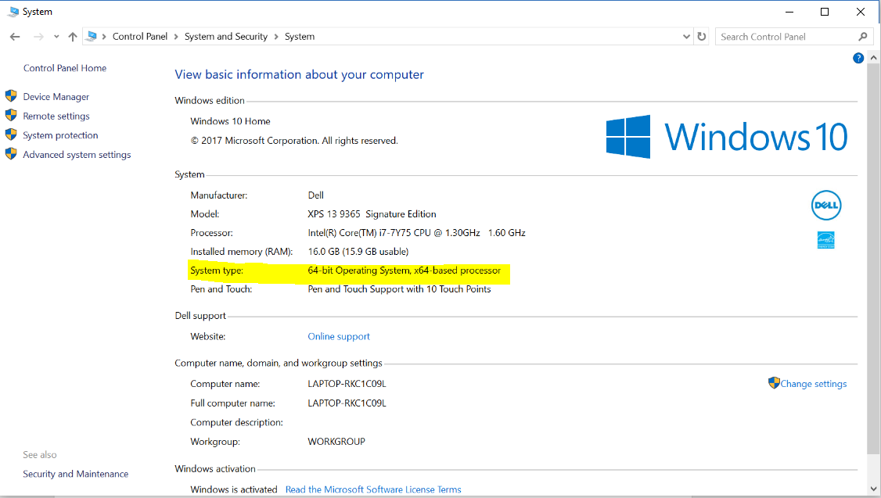

* 1. For Mac users:
     1. Follow the instructions on this link to determine what processor you have: <https://www.chiefarchitect.com/support/article/KB-01230/determining-if-your-computer-is-32-bit-or-64-bit.html>

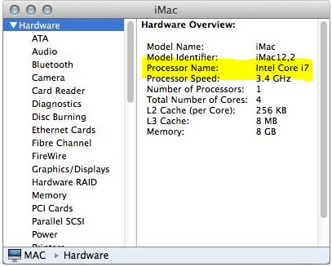 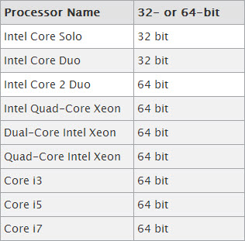

1. Download the 64 bit version of Python 3.6 for your operating system. The latest version can be found here: <https://www.python.org/downloads/release/python-363/>. You will want to install one of the items highlighted below depending on your operating system.

# Files

| **Version** | **Operating System** | **Description** | **MD5 Sum** | **File Size** | **GPG** |
| --- | --- | --- | --- | --- | --- |
| [Gzipped source tarball](https://www.python.org/ftp/python/3.6.3/Python-3.6.3.tgz) | Source release |  | e9180c69ed9a878a4a8a3ab221e32fa9 | 22673115 | [SIG](https://www.python.org/ftp/python/3.6.3/Python-3.6.3.tgz.asc) |
| [XZ compressed source tarball](https://www.python.org/ftp/python/3.6.3/Python-3.6.3.tar.xz) | Source release |  | b9c2c36c33fb89bda1fefd37ad5af9be | 16974296 | [SIG](https://www.python.org/ftp/python/3.6.3/Python-3.6.3.tar.xz.asc) |
| [Mac OS X 64-bit/32-bit installer](https://www.python.org/ftp/python/3.6.3/python-3.6.3-macosx10.6.pkg) | Mac OS X | for Mac OS X 10.6 and later | ce31f17c952c657244a5cd0cccae34ad | 27696231 | [SIG](https://www.python.org/ftp/python/3.6.3/python-3.6.3-macosx10.6.pkg.asc) |
| [Windows help file](https://www.python.org/ftp/python/3.6.3/python363.chm) | Windows |  | a82270d7193f9fb8554687e7ca342df1 | 8020197 | [SIG](https://www.python.org/ftp/python/3.6.3/python363.chm.asc) |
| [Windows x86-64 embeddable zip file](https://www.python.org/ftp/python/3.6.3/python-3.6.3-embed-amd64.zip) | Windows | for AMD64/EM64T/x64, not Itanium processors | b1daa2a41589d7504117991104b96fe5 | 7145844 | [SIG](https://www.python.org/ftp/python/3.6.3/python-3.6.3-embed-amd64.zip.asc) |
| [Windows x86-64 executable installer](https://www.python.org/ftp/python/3.6.3/python-3.6.3-amd64.exe) | Windows | for AMD64/EM64T/x64, not Itanium processors | 89044fb577636803bf49f36371dca09c | 31619840 | [SIG](https://www.python.org/ftp/python/3.6.3/python-3.6.3-amd64.exe.asc) |
| [Windows x86-64 web-based installer](https://www.python.org/ftp/python/3.6.3/python-3.6.3-amd64-webinstall.exe) | Windows | for AMD64/EM64T/x64, not Itanium processors | b6d61642327f25a5ebd1a7f11a6d3707 | 1312480 | [SIG](https://www.python.org/ftp/python/3.6.3/python-3.6.3-amd64-webinstall.exe.asc) |
| [Windows x86 embeddable zip file](https://www.python.org/ftp/python/3.6.3/python-3.6.3-embed-win32.zip) | Windows |  | cf1c75ad7ccf9dec57ba7269198fd56b | 6388018 | [SIG](https://www.python.org/ftp/python/3.6.3/python-3.6.3-embed-win32.zip.asc) |
| [Windows x86 executable installer](https://www.python.org/ftp/python/3.6.3/python-3.6.3.exe) | Windows |  | 3811c6d3203358e0c0c6b6677ae980d3 | 30584520 | [SIG](https://www.python.org/ftp/python/3.6.3/python-3.6.3.exe.asc) |
| [Windows x86 web-based installer](https://www.python.org/ftp/python/3.6.3/python-3.6.3-webinstall.exe) | Windows |  | 39c2879cecf252d4c935e4f8c3087aa2 | 1287056 | [SIG](https://www.python.org/ftp/python/3.6.3/python-3.6.3-webinstall.exe.asc) |

1. Begin installing Python: Follow the directions on the install wizard to finish installing. It is recommended that all check boxes are checked, specifically “add Python to PATH” for Windows. Proceed as you normally would install any application for Mac users.

A STANDARD installation is sufficient Windows users, a CUSTOMIZED installation is not necessary Windows users.

On the contrary, a CUSTOMIZED installation with all checkboxes checked is necessary for Mac users.

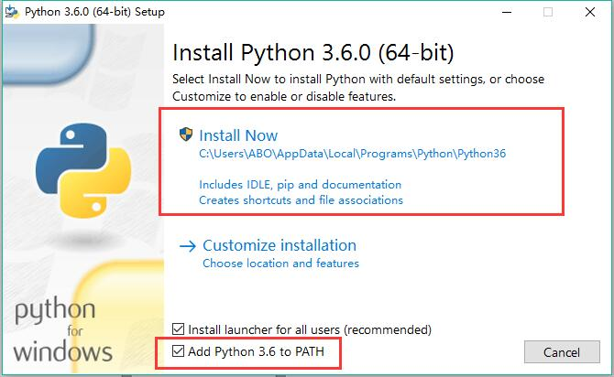

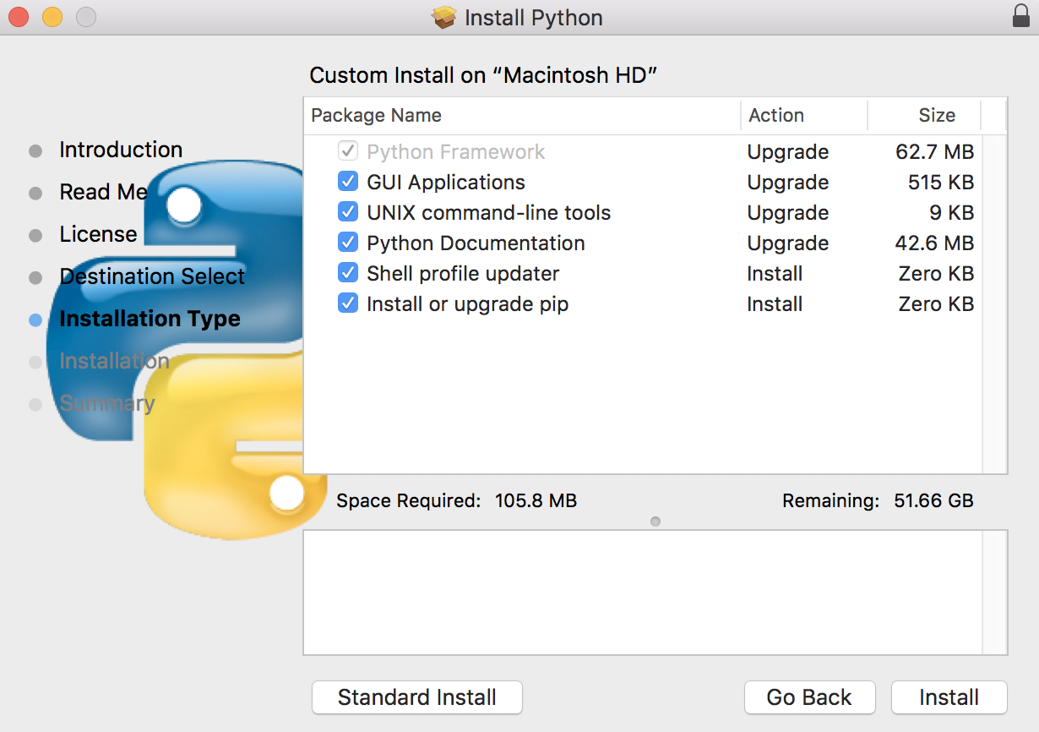

1. Ensure Python is fully installed and works:
   1. For Windows users open the command line by selecting “Start” > “Run” > and typing in “cmd” and hit Enter or search for “cmd” in the Start menu.
   2. For Mac users open terminal by going into Finder and selecting “Applications” > “Utilities” > “Terminal”.
   3. Check to see if Python works by typing “python” or “python3” in the command line or in terminal. Perform these quick calculations to make sure it’s working properly.

>>> 2+2

>>> print(“Hello World”)

>>> quit()

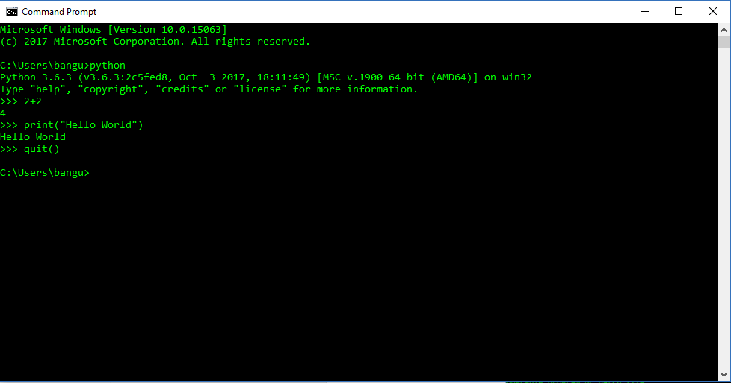

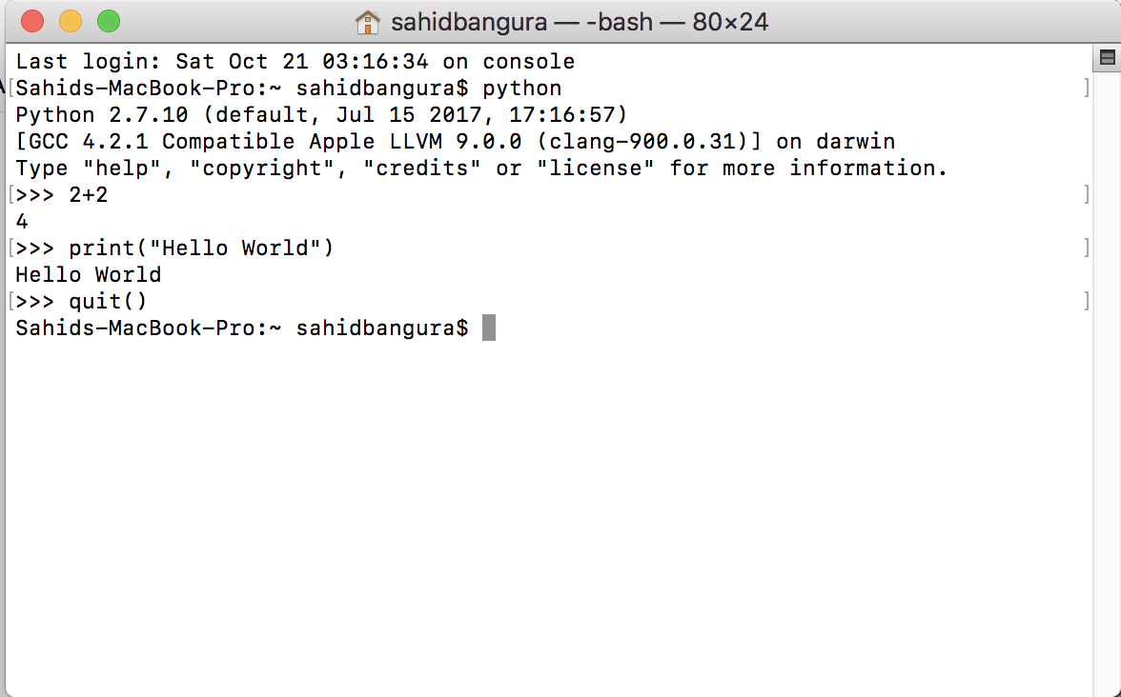

1. Install PyCharm: Make sure you download the free community edition located here:

<https://www.jetbrains.com/pycharm/>

NOTE: Install to the default location from the installer to avoid issues with finding the location of Python in PyCharm.

1. Install other Python modules using pip through the command line or terminal by typing:

pip3 install wheel

pip3 install ipython

We can take a look at all the modules pip has installed by calling:

pip3 list

When all the commands have been executed, you should see something like:

Windows:

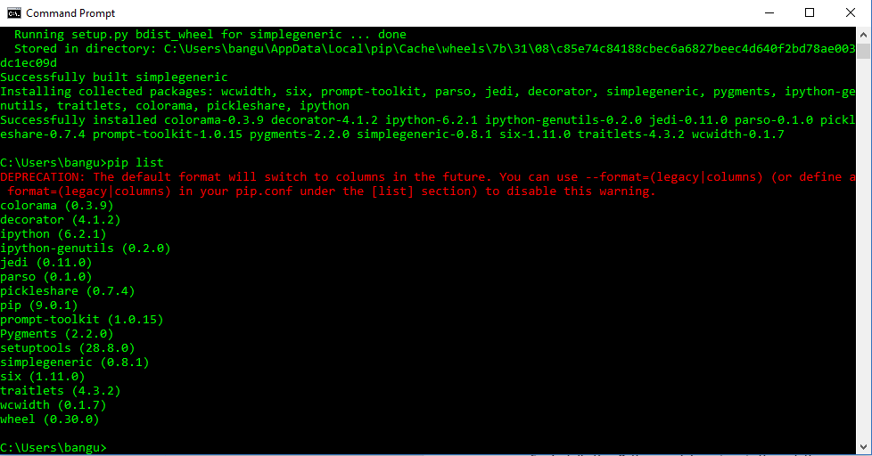

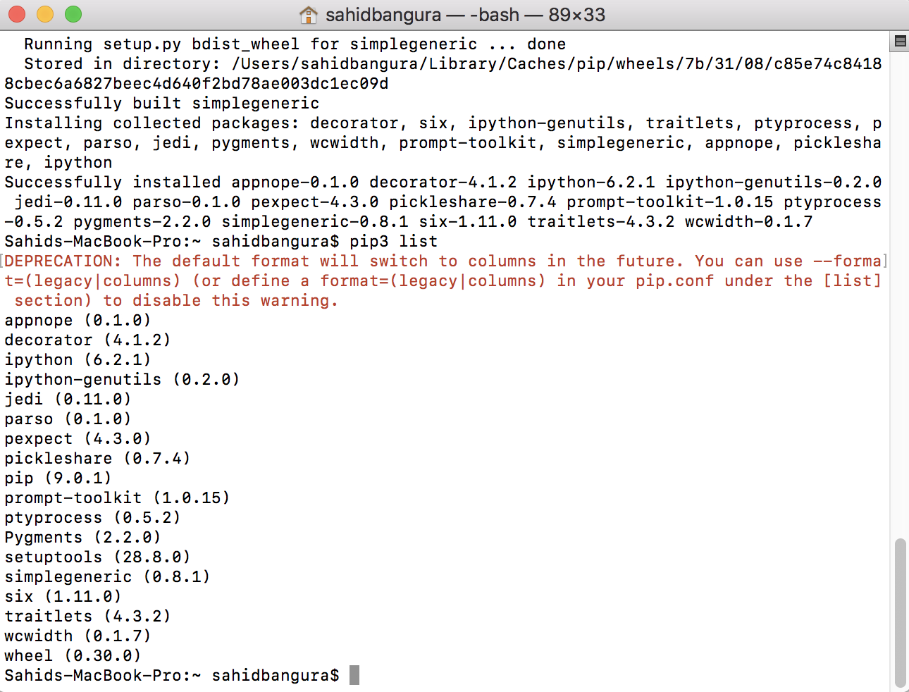

1. TensorFlow and the NumPy Stack:

For Windows:

BEFORE we install TensorFlow we need to install the NumPy stack. Specifically on Windows > pip install numpy MIGHT NOT work with certain modules that depend on Numpy for Windows, therefore we should install numpy+mkl. We can find the wheel file for the numpy+mkl instillation here at the un-offical python package index:

<https://www.lfd.uci.edu/~gohlke/pythonlibs/>

Numpy+MKL Version 1.13, CPython 3.6, Windows 64 bit. After the download we can open the command prompt and chage directory into the Downloads folder.

cd Downloads

pip3 install numpy‑1.13.3+mkl‑cp36‑cp36m‑win_amd64.whl

For Mac:

Simply install the NumPy stack in terminal by typing:

pip3 install numpy

1. Install Machine Learning Libraries and the NumPy Stack (NOTE: This might take a while). Type in the command line or terminal:

pip3 install tensorflow pandas matplotlib scipy keras

1. Now we can run our first “Hello World” in TensorFlow!

Open PyCharm and create a new Project (use the default Interpreter location):

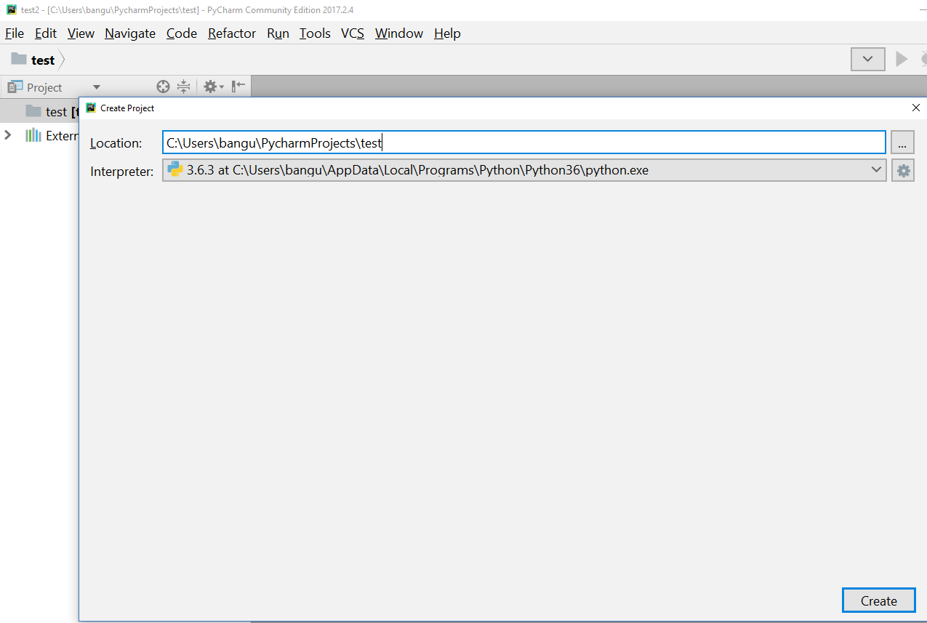

Once the project is created, right click on the project name of the left panel and select “New” > “Python File”. A new Python File will be created.

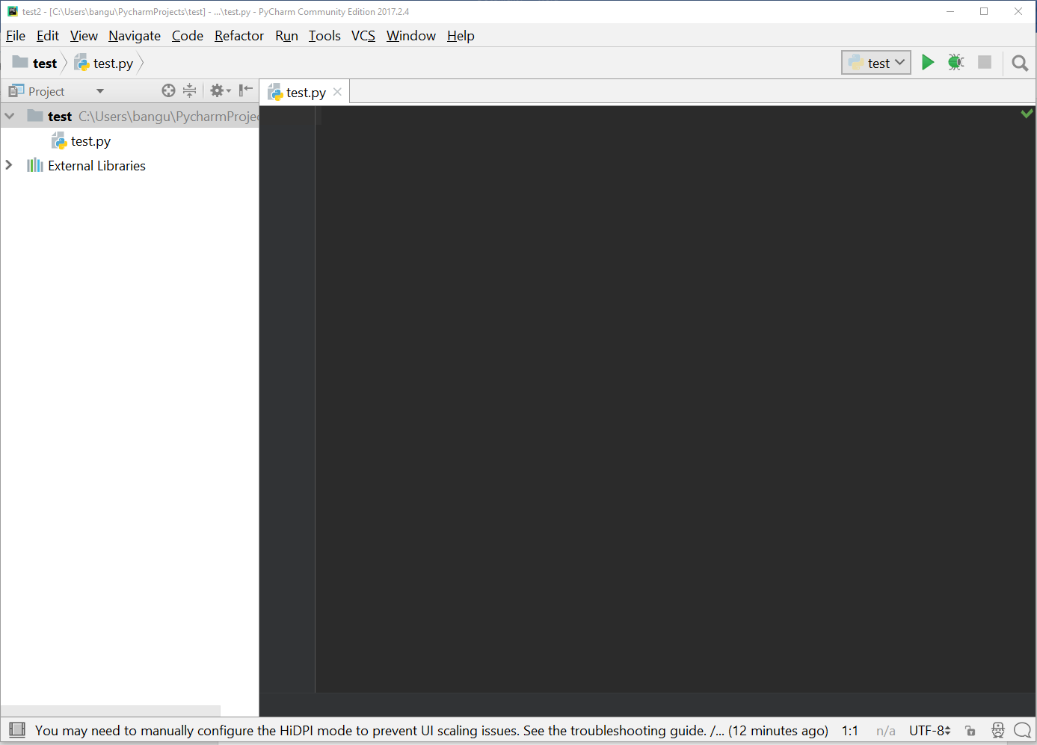

Enter this code in:

import tensorflow as tf

hello = tf.constant('Hello, TensorFlow!')

sess = tf.Session()

print(sess.run(hello))

If everything is successful, you should see in you console (you can ignore the warning):

b'Hello, TensorFlow!'

Process finished with exit code 0

As well as the screenshot below:

